The Australian Story – the National Health Services Directory (NHSD)

Key Metrics
- A “Single Source of Truth” for Health and Social Care providers, consumers and health planners
- National Health Services Directory – 400,000 + services
- National Provider Directory - 300,000 accredited healthcare professionals
- National Telehealth Directory
- Supports the free flow of data and interoperability across eight (8) states and territory jurisdictional borders
- 9.5 million transactions per month
- Incorporates Public, Private and Not for Profit, organisations in one National directory
- Eliminated 163 Provider Directories in Victorian State Public Hospitals alone
- Stores national health identifiers for secure messaging:
- Health Provider Identifiers: Individual (HPI-Is)
- Health Provider Identifiers: Organizational (HPI-Os)
- Secure Messaging End Point Location Service (ELS)

Background
Accessing consistent, authoritative and reliable information about health and social care services is important for consumers, health practitioners, and policy planners. Both service and provider information must be available quickly, easily and with the highest possible degree of accuracy and reliability alongside appropriate identification and messaging.
In practice, hospitals, GPs, disability services, all have a myriad of directories for multiple providers that traverse geographic boundaries; they are usually kept in spreadsheets on local systems or in hardcopy books. This information is used daily by doctors, nurses, and allied health professionals to aid the transfer and management of care.
Situation
The Australian National Health Services Directory (NHSD) started its life in 2006 as the Victorian Health Services Directory has been incrementally developed to provide better and more effective functionality over several years in conjunction with consumers and health/human services provider’s business requirements. It has proven to be scalable and sustainable, all from the “Cloud”. It was in response to an increasing frustration initially from health professionals about the overlapping nature of finding information and inconsistent type and quality. It also contributed to problems in the uptake of e-health. In-house or segregated databases cannot sustain electronic communications information or link to health identity (accreditation) services; the consent and management regimes are highly variable; maintenance costs are duplicated, and health service providers do not want to respond to a myriad of requests to insert and maintain their information into the various directories.
A pilot was initiated with one state, Victoria, initially consolidating 160 provider and practitioner directories. The Victorian Human Services Directory fulfilled the initial function as a single repository of human and health service data including:
- service and practitioner details
- contact information such as opening hours, location
- identifiers for organisations and providers
- geo coded service locations
The success of the pilot meant that other states had confidence to follow suit. The Australian Capital Territory (ACT) started to use it for their health consumers and organisations, the Northern Territory (NT) as a Directory to hold Electronic Identifiers for Secure Messaging between all health and human services. This was the first time that two or more states collaborated to share their data in a single directory.

Key Metrics
Provides:
- Consumer access to find services nearest them using their smartphone
- Secure messaging for healthcare providers for discharge summaries, referrals, etc.
- The basis for a local, state and national health data mapping platform , using advanced data analytics
- “widgets” (self-contained web applications that can be embedded on a website) that provide discrete pieces of functionality, they can be easily shared with other organisations, allowing them to take advantage of the functionality and data of the NHSD, without having to duplicate or create their own content or applications..

The National E-Health Transition Authority (now the Australian Digital Health Authority), an organisation supported by all States and Territories and the Federal government, recognised the success of individual state service directories. Following a meeting of all State CIO’s, the major private hospital and pathology providers, unanimous agreement was reached that there should be a National Service Directory combining service and provider directories across all state jurisdictions.
Key Components of Developing a National Directory
Crucial delivery points in the successful rollout of the NHSD included:
- seeking endorsement from the primary care providers
- building a brand that both providers and consumers have high levels of confidence
- appointing a third-party provider to oversee the directory, ensuring independence of state/province jurisdiction

Lessons Learned
The Australian NHSD is one of the first of its kind in the world. During the evolution of its’ development some key learnings should be considered for future projects.
- A strong marketing strategy and campaign aimed at health professionals and the community.
Any application is only as great as its uptake. The Australian NHSD acceptance was much slower than what it might have been, had a robust marketing plan been implemented.
- Extensive consultation and support from key bodies – will ensure that consumer groups, not for profit groups and peak bodies have early buy-in of the project.
- Sponsorship from senior government officials – mean greater opportunities for funding, access to peak bodies and greater opportunity to use data.
Key Benefits in the Australian Context
- National Healthcare provider identifiers
Consistent service identifiers provide a stable foundation for other service access options such as TeleHealth and GP After Hours services. Agreeing to a consistent methodology to identify each health service, professional and provider means that services are easily identifiable and mappable. It also creates a national system where discharge summaries are transferred between services easily, e-prescriptions systems can be implemented with greater speed.
- Evidence based planning
The Australian NHSD is a shared piece of national infrastructure and allows stakeholders to have varying degrees of control. Making the NHSD infrastructure ubiquitous has built a community of positive support because of its utility and ease of availability.
An example of a software product integrating the NHSD is the National Healthmap data platform. This platform aims to help overcome the “islands of data” held across the health sector by combining the NHSD with a range of relevant health data sets, including census demographics, disease prevalence, and health outcomes.
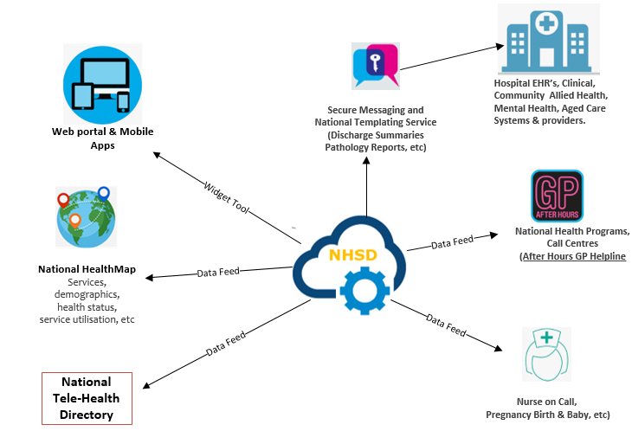

The Healthmap demonstrates how the NHSD can be extended from its primary role as a foundation for national E-Health initiatives to a health data tool supporting policy makers, health planners, and researchers in their broader roles of improving population health outcomes through evidence-based decision making
Visualization of data is extremely effective in bringing complex datasets to be together to convey information in a simple Geo-Spatial (Google Maps) format. The National Healthmap uses data from the NHSD, from which we can introduce a wide range of national datasets (e.g., census) and local health datasets to support a greater focus on evidence-based planning and decision making.

